**VIT-AP UNIVERSITY, ANDHRA PRADESH**

**CSE3003 – Computer Networks - Lab Sheet: 10**

**Academic year:** 2023-2024  **Branch/ Class:** B.Tech

**Semester:** Fall  **Date:**

**Faculty Name:** Prof. S.Gopikrishnan  **School:** SCOPE

**Student name:Aman Sahu Reg. no.: 22BCE7224**

**FTP Server**

**Q1:**

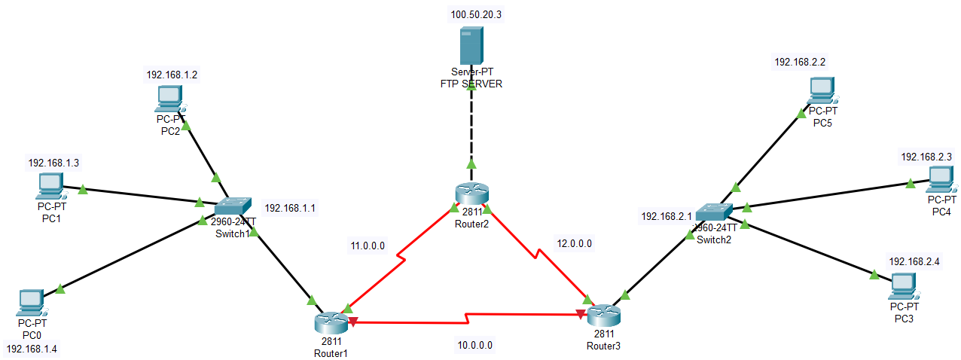

**Objectives:**

1. Design a network using three routers and switches with 3 - 4 PCs each and one FTP server in the network.
2. Configure all the routers with any routing scheme.
3. Configure all the servers.
4. Verify the servers working.

**Verification and expected output:**

1. Txt file which is stored in FTP server should be accessible by any other PC
2. Ensure all text file should be access via individual username and password by each PC only.
3. Create sample file from one PC and upload to FTP Server and access it from other PC through FTP
4. Screenshot of each successful upload of a file to FTP server.
5. Screenshot of each successful download of a file to FTP server.
6. Username and password credentials of all pc should be tabulated.

